San Jose State University

EE250 (Section 2) Fall 2019 Prof. Kamali

Solution to Problem Set #4

- Problem 4.67
a)

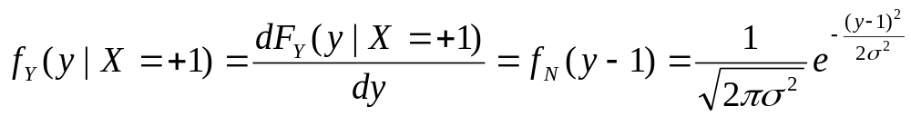
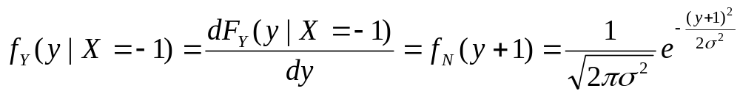

b) Decide 0:

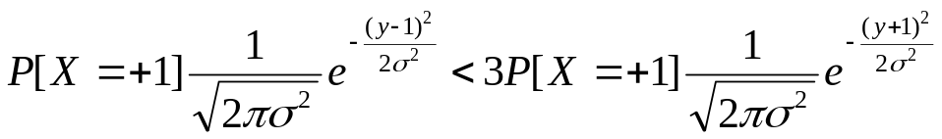

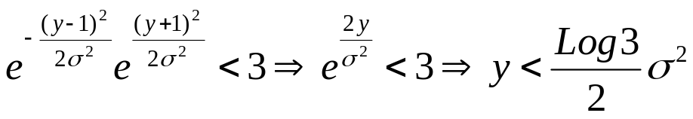

Thus 0 is decided if 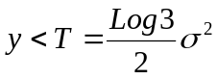 and 1 is decided otherwise.

c) 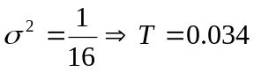

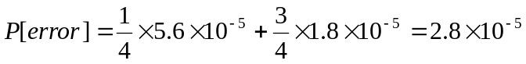

- Problem 4.78
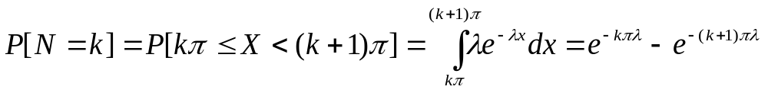
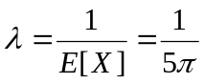

Thus
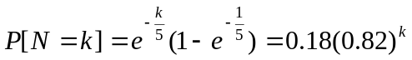 Geometric Random Variable

- Problem 4.91

a) 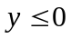, 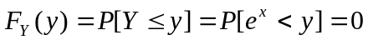

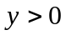,

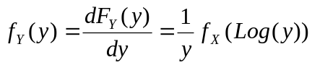

b) 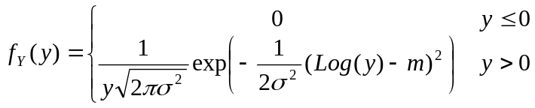

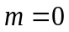, 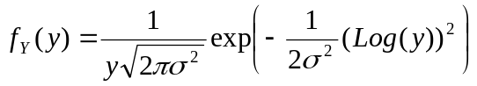
Pdf of Y is shown for two case in the following.

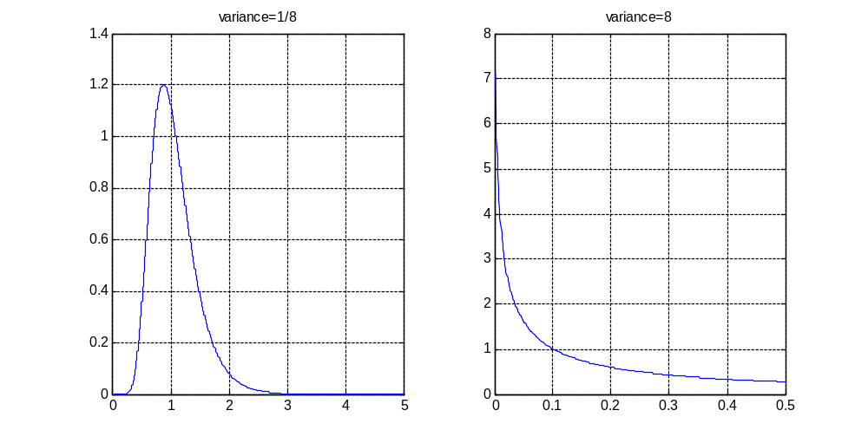

- Problem 4.100

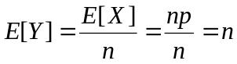

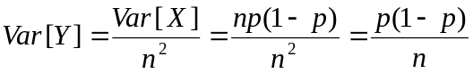

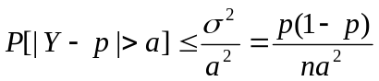

As , 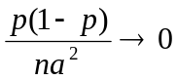 and thus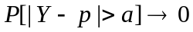 (for fixed ).

- Problem 4.104
Looking at Table 4.1,

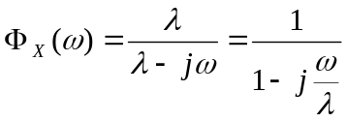
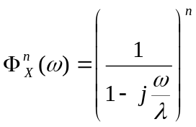 which is the characteristic function of the m-Erlang distribution.

- Problem 4.119

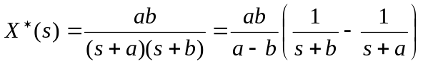
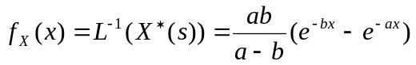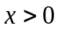

- [Midterm, Fall 2011] The DC power dissipated in a resistor is 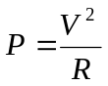where 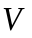is the voltage across . Let us assume 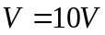and has a uniform distribution between 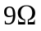and 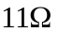. Find the pdf of the dissipated power .

Solution:
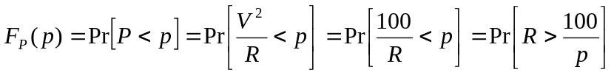

We note that if 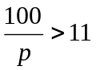or 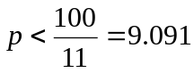, then 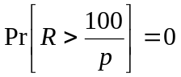

Also if 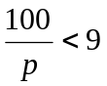or 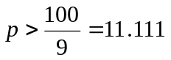, then 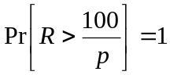

For 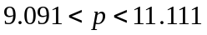, 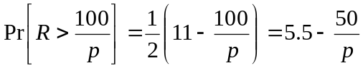

Therefore

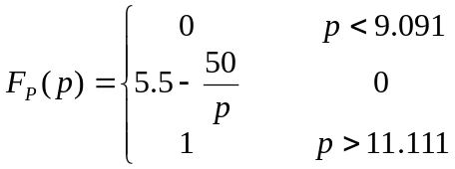

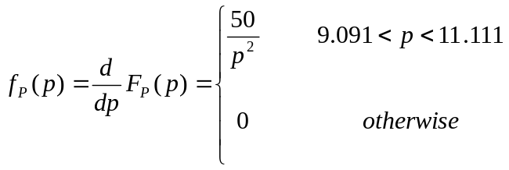

- [Midterm, Spring 2009] In wireless systems with smart antenna, there are more than one channel between the transmitter and the receiver and the latter can use both received signals to improve its estimate of the transmitted message. Consider the following system where 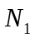and 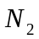are two independent noise sources which are zero mean and unity variance Gaussian random variables. The input can be +1 or -1 and 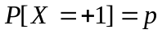. The input is naturally assumed to be independent of and .

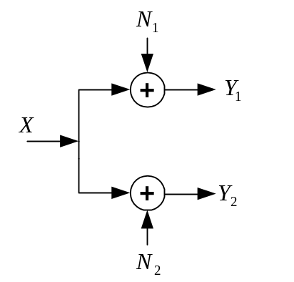

- Find 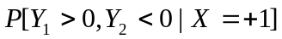 and 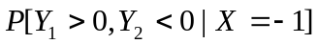.
- Find 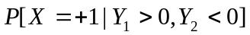.
- If 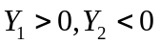, what is the best estimate of if 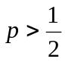and if 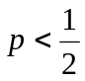.

Hint: 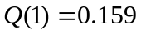

Solution:
a)

b)
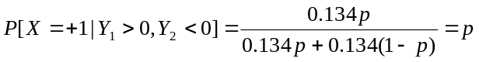

c) If , 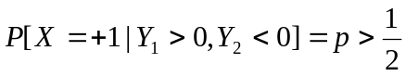 and thus 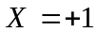is the best estimate.
If , 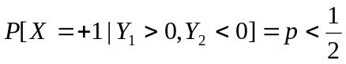 and thus 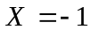is the best estimate.

- [Midterm, Fall 2009] Suppose the input to an Analog to Digital Converter (ADC)is a continuous random variable with pdf 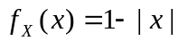 for 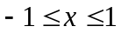. What dynamic range  must be chosen for ADC to keep the probability of clipping at 4% (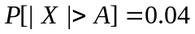)?

Solution:

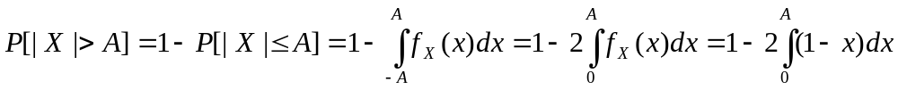

Since 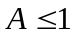, the only acceptable solution is 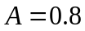.

- [Midterm, Spring 2009] The pdf of a continuous and non-negative random variable satisfies the following equation.

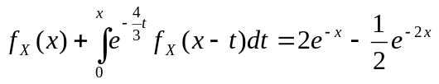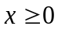

Find 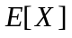and 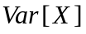.

Hint: First find the Laplace Transform of 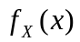.

Solution:
The integral in the above equation is simply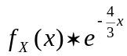. Taking Laplace Transform of both sides of the above equation we have/

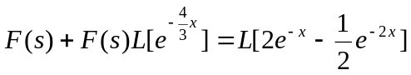
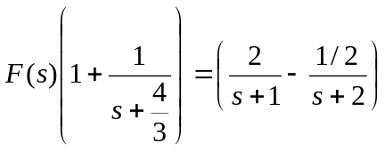
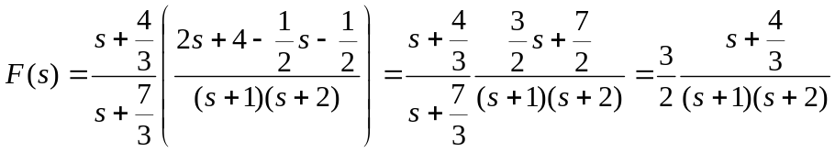

We can now find and directly from 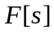. But we prefer to compute .

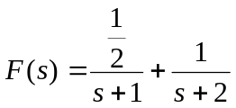

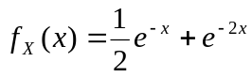

To find and , we need the following integrals.
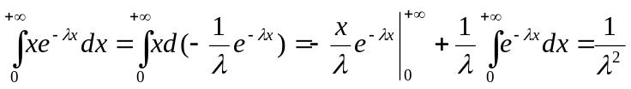
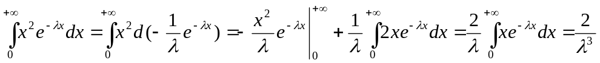
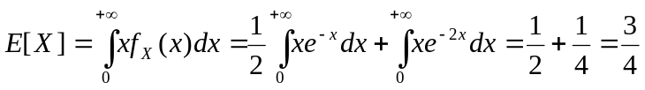

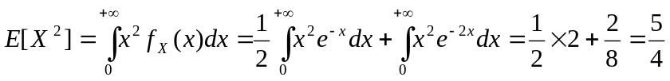

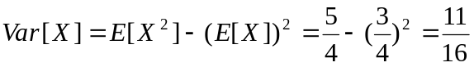

- [Midterm, Spring 2014] The Probability Generating Function (PGF) of the discrete random variable 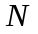 is 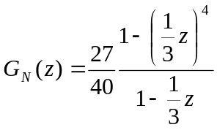.

a) Find the probability mass function (pmf) of .
b) Find 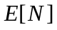.

Solution:
a) 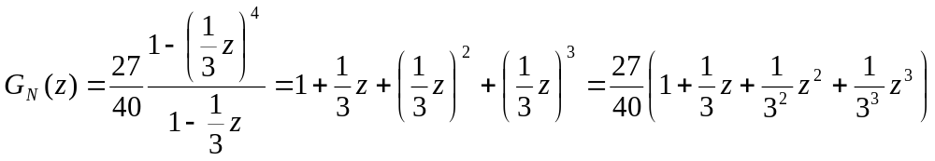

Noting the definition of PGF as 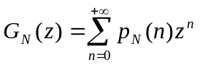, we conclude that 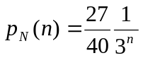for 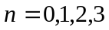.

b) 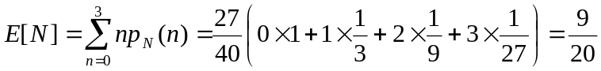

- [Midterm, Fall 2015] Find the pdf of 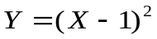 if is a uniform random variable between 0 and 2.

Solution:

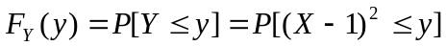

Clearly if 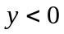, 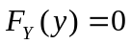. Also from 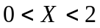 , we conclude that 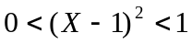 and thus 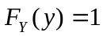for 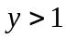.

For 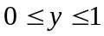,

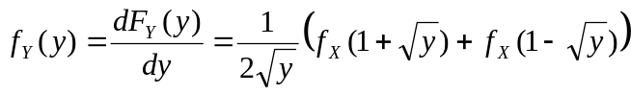

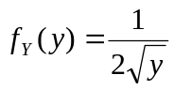
- [Midterm, Fall 2017] Consider a communication channel whose output is related to its input through the following equation.

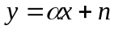

where 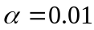is the channel gain and is a zero mean Gaussian noise with the standard deviation of 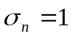mvolt. Input signal is one volt. At the receiver, an Analog to Digital Convertor (ADC) converts to digital. When designing ADC, we fix its input range and when the input signal () exceeds the range of ADC, clipping happens which is undesirable. Find the probability of clipping if the ADC range is 15mvolts.

Q Function
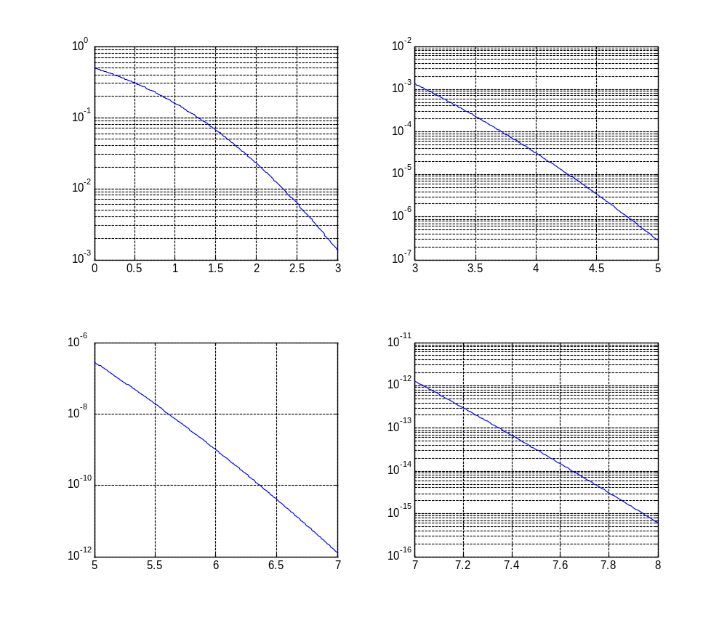
Solution:
Clipping probability: 